(Insert Date)

Dear Local RCMP or Local Police Force,

(COACH NAME) is a volunteer who will be occupying a role as a (INSERT ROLE) with a (INSERT AGE CATEGORY) sanctioned team under Hockey Manitoba during the 2026-27 hockey season where they will have access to vulnerable individuals.

Hockey Manitoba is a not-for-profit provincial sport organization for the sport of hockey within the province of Manitoba. In cooperation with (INSERT MHA), Hockey Manitoba oversee the certification and screening of all coaches and team staff within its governance.

In accordance with Hockey Manitoba's Screening Policy, all coaches and team officials are required to complete a Criminal Record Check including the Vulnerable Sector Check by December 1st of the applicable hockey season to be eligible for their role.

I ask that you assist the volunteer in processing their Criminal Record Check and Vulnerable Sector Check. After the check is completed, the volunteer will return the results to their applicable Minor Hockey Association for review and record keeping.

Should you have any questions, please contact Dustin Stewart at 204.926.8355 or via email at dstewart@hockeymanitoba.ca

Thank you for assisting us in creating a fun and safe environment for participants of Hockey Manitoba.

Sincerely,

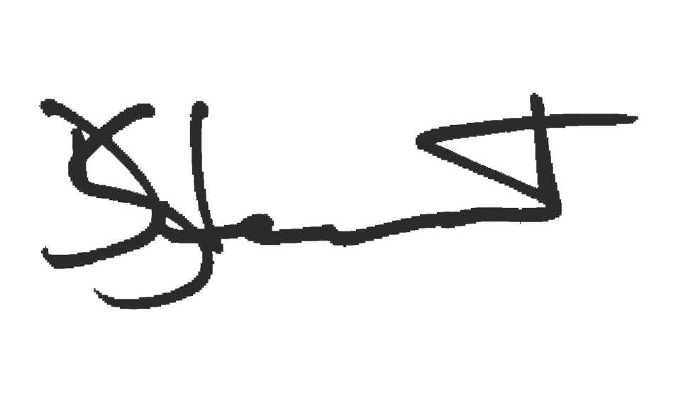

Dustin Stewart
Manager, Operations
Hockey Manitoba

